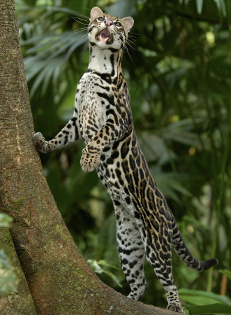

### Recycling is **your** responsibility!

# Rainforests are being destroyed everyday because more paper needs to be produced. We can do our part to save the rainforest by recycling paper so more trees can be preserved. Instead of throwing away used paper and cardboard, please recycle and save the wildcats in the rainforest.

Experts estimate that the last remaining rainforests could be consumed in less than 40 years.

* Wildcats Recycle

It is our responsibility to help

Ms. Wilson STEAM CAMP 2014

!