Rainforest Animal Research Notebook

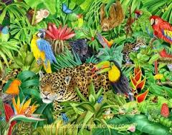

I am researching about

_________________________

What I think I know about my animal…

Where my animal lives…
(habitat)

What my animal eats…
(appetite)

What my animal looks like…
(appearance)

My animal needs…

Interesting facts about my animal…

Illustrations of my animal…

